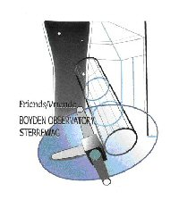 | FRIENDS OF BOYDEN  Membership Form  www.assabfn.co.za/friendsofboyden | 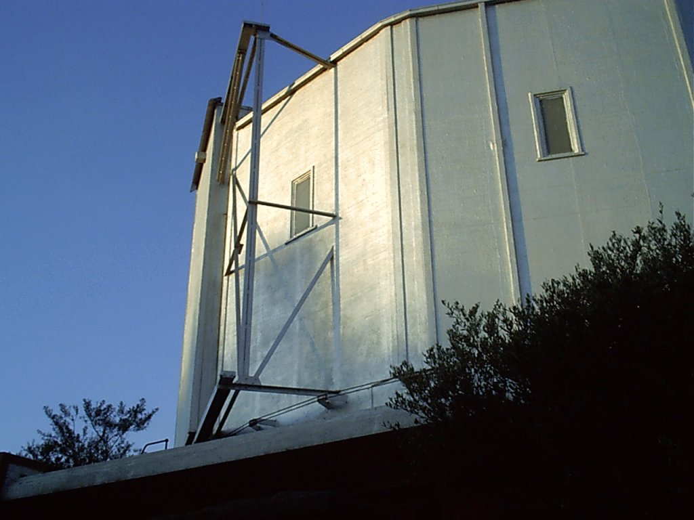

Particulars:

Title:_______ Name & Surname:___________________________________________
Postal address:__________________________________________________________
______________________________________________________________________
______________________________________________________________________
Tel (h):____________________Tel (w):_________________ Fax:________________
Cell nr: _______________________
E-mail address:_________________________________________________________

Type of membership:

Ordinary member: R40 (1 person) |  | Family member: R50  (more than one person) |  | Lifelong member: R300
Student/pensioner (R20) |  | Society member: R150 |  | Compnay member: R150
Donation:

Total amount included with this form:______________

Signature: __________________________

Contact / send to:

Braam van Zyl
PO Box 13004
Brandhof
9324

Albrecht Street 75, Dan Pienaar

Tel nr: 051 – 436 7555 (h)
Or e-mail: jalvzyl@mweb.co.za

Electronic / direct payment:

Friends of Boyden Observatory Cheque account
Maitland Wes branch (Bloemfontein)
Account number: 0470 184 086
Please indicate your name as reference or send proof of payment to above fax nr. / e-mail.

