Solar Observation 

By: Jacques van Delft jvdelft.solar@starmail.co.za
Director Solar section Cell +27 (0) 82 – 812 5907

Solar observation in Southern Africa is an open field of research for amateur astronomy. There are only a few amateurs in Southern Africa that do solar observation by means of Sunspot counting’s or SID (Sudden Ionosphere disturbance) observations. I’ve been doing research for more than twenty years on the influence from solar activities on climatic change.

We in Southern Africa are very fortunate to have much more open skies than in the northern hemisphere. Solar observation in the northern hemisphere is far more developed than here in Southern Africa. We can therefore contribute a lot to the science of solar activities. We need to encourage people with interest to do solar observations in different ways and build a local database, which we can share with international organizations.
At the moment individual submissions of sunspot counting’s are done for the solar section of the AAVSO group in the USA on a monthly basis. From there an international sunspot database is built. Sunspot photographs are sent to the solar section of the ALPO group in the USA. They have a website where they publish these pictures from were it can be used by scientists, newspapers, magazines etc.

In February 2004 we started to publish solar observations in a solar bulletin which is published on the Internet on the website of the Bloemfontein branch of ASSA as well as the national ASSA site (http://assa.saao.ac.za). Visit the site at www.assabfn.co.za and click on the solar activities link.
This bulletin is used not only to give recognition to the observers that contribute, but will also be a reporting platform of solar activities observed in Southern Africa.

At the moment two members do sunspot observations and submit their counting’s to the ASSA Solar section. The average number per observer per day calculates the monthly Rz sunspot number, for that month. The more observers participating in the counting of sunspots, the more accurate this Rz number will be.

We’re in astronomy for deep sky, variable stars, comet etc. “the bigger the telescope the better” – but in solar observations it is not always the case.

Even a reasonably small telescope ( max 50 – 75 mm ) will give very good results. I started with a homemade 40mm refractor telescope from which the outer lens at the front had a few cracks. My first pictures of sunspots were published on the ALPO website with good reaction on the quality of the details visible.
If you have a bigger telescope, you need to make a mask that covers the front of your telescope. The opening must not exceed 75 mm because of the heat from the amount of light entering your telescope that will build up on the eyepiece.

Two methods are used for the observation of sunspots: the projection method and the direct view method with the aid of special solar filters.
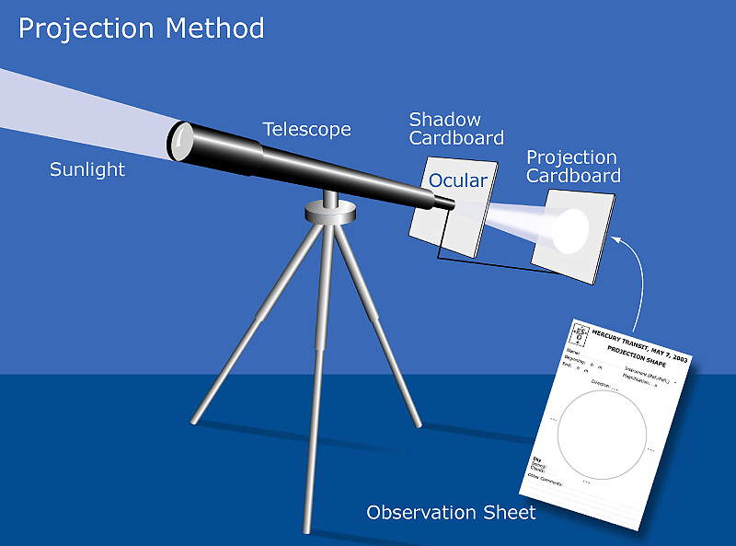
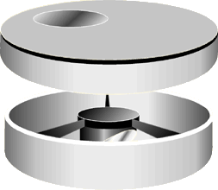

Projection method Mask for direct view method

The projection method is not only less expensive, but the advantage is that more than one person can observe the solar disc at the same time . For the direct view method you need to cover the mask opening with Maylor - or Baader filters. More expensive filters can also be used.

The history and the way sunspots are counted, is very well explained in a document called “Dances with Wolf’s” from the solar section of the AAVSO group. The ASSA solar section will submit documents on how sunspots are counted and recorded when you become a observer and submit data.

Why not start a solar section in your ASSA branch? To share your observations or research efforts in your regular meetings is very rewarding.

For more information or help getting started with observing, please feel free to contact me on the above e-mail address or cell phone number.

Regards,

Jacques.

