Deep Sky list for September 2006

Binoculars and telescopes (binoculars recommended 10x50 and up)
1. M10 – Globular Cluster in Ophiuchus (strong binocular, medium telescope). Mag 6.7, Size 12.2’
Comments:

2. M12 – Globular Cluster in Ophiuchus (strong binocular, medium telescope). Mag 6.6, Size 12.2’
3. M8 – Bright Nebula in Sagittarius (Lagoon) – Eye/Binocular. Mag: 5.0, Size 45.0'x30.0'
4. M20 – Bright Nebula in Sagittarius (Trifid) – Strong binocular, Small tel. Mag: 6.3, Size: 28.0'
5. Lyra’s “Double Double” stars - 4 Epsilon(1) & 5 Epsilon(2). Both are doubles in turn.
Use strong binocular, small telescope to dissolve all doubles

Telescopes only (minimum 6 inch and up, recommended 8 inch and up)
6. M11 – Open Cluster in Scutum (Wild Duck). Mag: 5.8, Size: 14.0' Astrophotographser’s choice!
7. NGC 55 – Very large Galaxy in Sculptor – Magnitude: 8.4, Size: 31.2'x5.9' (!)
8. NGC 253 – Very large Galaxy in Sculptor - Magnitude: 8.0, Size: 26.4'x6.0' (!)
9. M27 – Large planetary Nebula in Vulpecula (Dumbell Nebula). Magnitude: 7.6, Size: 5.8' – Regarded by most as THE best planetary nebula in the sky, on par with the Ring Nebula in Lyra. Astrophotographser’s choice!
10. M57 – Planetary Nebula in Lyra (Ring Nebula). Mag.: 9.7, Size: 1.2'. Astrophotographser’s choice!

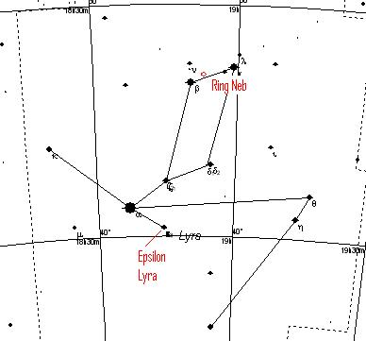

Lyra – North

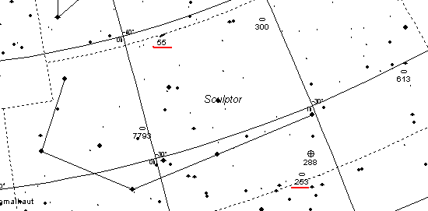

Sculptor

