ASSA Bloemfontein Deep Sky list for June 2006

Binoculars and small telescopes (binoculars recommended 10x50 and up)
1. Coma Berenices Star Cluster (naked eye/binocular wide field, 37 cluster members).
Comments:

2. IC 2602 – Open cluster in Carina (Southern Pleiades) Magnitude: 1.9, Size: 100.0'
3. NGC 3532 – Open Cluster in Carina (Wishing well cluster) Magnitude: 3.0, Size: 50.0'
4. . NGC 3372 – Nebula in Carina (Keyhole nebula) Magnitude: 3.0, Size: 120.0'
5. NGC 5139 – Globular cluster in Centaurus (Omega Centauri) Magnitude: 3.7, Size: 36.3'
Telescopes only (minimum 6 inch and up, recommended 8 inch and up)
6. NGC 3766 – Open Cluster in Centaurus (Pearl cluster). Magnitude: 5.0, Size: 14.0'
7. M3 (NGC 5272) – Globular Cluster in Canes Venatici. Magnitude: 6.2, Size: 18.6'
8. NGC 4833 – Globular Cluster in Musca. Magnitude: 6.9, Size: 13.5', 21 200 light years away
9. NGC 3132 – Planetary Nebula in Vela (Eight Burst nebula). Magnitude: 8.0, Size: 48.0"
10. M83 (NGC 5236) – Galaxy in Hydra (Southern Pinwheel). Mag.: 8.0, Size: 13.1' x 12.2'

Northern skies (improve quality by expanding the image by clicking on it and dragging it out):

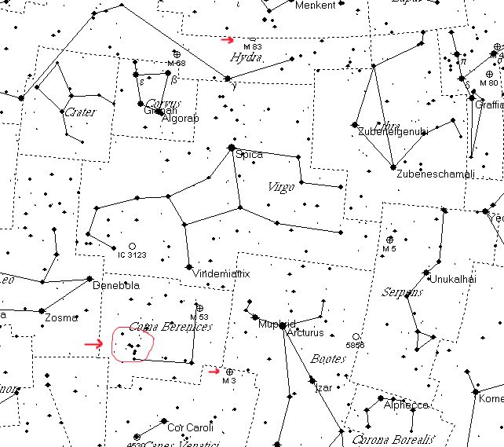

Southern skies (improve quality by expanding the image by clicking on it and dragging it out):

